Fast**National University of Computer & Emerging Sciences, Karachi  
Fall-2020 - Department of Computer Science**

|  |  |
| --- | --- |
| **Course Code: CS211** | **Course Name: Discrete Structures** |
| **Instructor Names: Dr. Fahad Samad, Mr. Shoaib Raza and Ms. Bakhtawar Abbasi** | |
| **Student Roll No:** | **Section No:** |

**Bachelor of Science (Computer Science)  
Midterm 2 Examination-- Solution  
November 24, 2020, 01:15 pm – 02:15 pm**

**Instructions:**

* Return the question paper together with the answer script. Read each question completely before answering it. There are **3 questions and 2 pages.**
* In case of any ambiguity, you may make assumption. But your assumption should not contradict any statement in the question paper.
* Attempt all the questions in given sequence of the question paper.

__________________________________________________________________________________________________________________________________________________________________________________________**Total Time**: 60 minutes **Maximum Marks**: 24

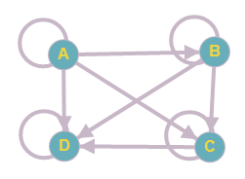**Question # 1 (Relations) [ 2 x 4 = 8 Marks]**

(a) Draw the digraph of the following matrix.

Solution:

R =

(b) Determine whether the relation in part (a) is an equivalence relation? Show all of your steps.

Solution:

No, it is not an equivalence relation. Since it is Reflective and Transitive but not Symmetric.

(c) Find the composition of relations R1 and R2, Where R1 is the relation from {1,2,3} to {2,4,6,8} with R1 = {(1, 2), (1, 6), (2, 4), (3, 4), (3, 6), (3, 8)} and R2 is the relation from {2,4,6,8} to {s,t,u} with R2 = {(2, u), (4, s), (4, t), (6, t), (8, u)}.

Solution:

R2 ◦ R1 = {(1, u), (1, t), (2, s), (2, t), (3, s), (3, t), (3, u)}.

(d) Determine whether the given relation(R) is a partial-order relation on A= {1, 2, 3, 4, 5}? Show all of your steps.

R= {(x, y) | 3 divides x + y}

Solution:

R= {(4,1),(5,2)}. It is not Partial-order relation as it not holds Reflexive and Symmetric property.

**Question # 2 (Graph Theory) [ 2 x 4 = 8 Marks]**

(a) Determine if the following two graphs ***G and G’*** are isomorphic. If they are, give function ***f: V (G) → V (G’)*** that define the isomorphism. If they are not, give the reason why?

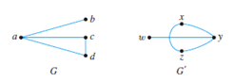

Solution:

Function f: V (G) →V (G’): f(a) = y, f(b) = w, f(c) = x or z & f(d) = z or x

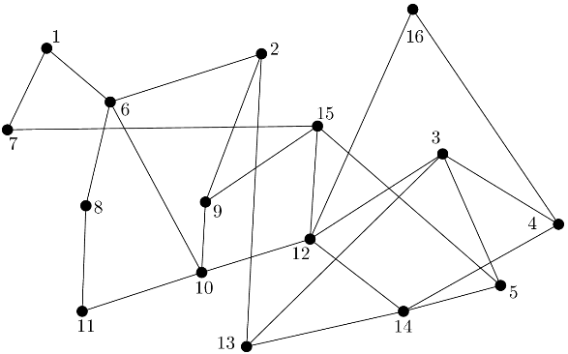(b) Determine if the following graph is bipartite. If it is then show the bipartition. If it is not, then show where the violation occurs.

Solution:

Yes, the graph is bipartite. The bipartition of the vertices is A={1,2,3,8,10,14,15,16} and B={4,5,6,7,9,11,12,13}. Notice that the only edges in the graph are between the set A and set B.

(c) (i) Is there a graph with 50 vertices, such that exactly 19 vertices have degree 3, and the remaining 31 vertices have degree 8?

Solution:

No, there is no with 50 vertices, such that exactly 19 vertices have degree 3, and the remaining 31 vertices have degree 8. Since (19*3) +(31*8) ≠ 2e

(ii) How many vertices does a graph of degree six with 30 edges have?

Solution:

Let N be the total number of vertices. According to handshaking theorem $\sum_{u∈V}{deg V}$ = $2\left|E\right|$

Since degree of every vertices is 6, therefore sum of the degree of all vertices can be written as N *6.

Put the values in above equation,

N*6 = $2\left|E\right|$ implies N= (2*30)/6 = 10. Hence total vertices are 10.

(d) Determine if Euler and Hamilton circuits exist in ***Graph H.*** If yes, show the circuit, if not explain why?

Solution:

No Euler circuit because two vertices (c, f ) have odd degree.

Hamilton Circuit is: c, b, a, f, e, d, c.

**Question # 3 (Number Theory) [ 2 x 4 = 8 Marks]**

(a) A message has been encrypted using the function f(x) = (x + 5) mod 26. If the message in encrypted form is ***VZJXYNTS UFUJW***, decrypt the message.

Solution:

QUESTION PAPER is the encrypted message.

(b) Using Bezout’s theorem, find the inverse of 57 modulo 100.

Solution:

Gcd(a,m)= 1= as + tm Gcd(57,100)= (4)(100) + (-7)(57) = 1

Hence Inverse is -7 OR -7+100 = 93.

(c) The first nine digits of the ISBN-10 of the European version of the fifth edition of a book are 0-07-119881. What is the check digit for that book?

Solution:

1*0 + 2*0 + 3*7 + 4*1 + 5*1 + 6*9 + 7*8 + 8*8 + 9*1 + *x*10 = 0 mod 11

0 + 0 + 21 + 4 + 5 + 54 + 56 + 64 + 9 + *x*10 = 0 mod 11

213 + *x*10 = 0 mod 11

Check digit, *x*10 = 4.

(d) Use Fermat’s little theorem to solve 72019 mod 13.

Solution:

Since 712 = 1 (mod 13)

= (712 )168 .73 mod 13 = 73 mod 13 = 5.

***ALL THE BEST***